THE IMPORTANCE OF ANIMAL RESCUE| 1

***Title of Term Paper***

|  |
| --- |
| THE IMPORTANCE OF ANIMAL RESCUE IN BANGLADESH |

***Course Title***:

**Composition and Communication Skills**

***Course Code***:

**ENG 102**

**Section-2**

***Submitted By***:

|  |  |
| --- | --- |
| Name | ID |
| Nayma Amin Nishy | 2021-3-60-178 |
| Sidratul Moontaha | 2021-3-60-048 |
| B M Shahria Alam | 2021-3-60-016 |
| ­Arman Sheikh | 2021-3-60-015 |

***Submitted to:***

**Syeda Shabnam Mahmud**

**Lecturer**

**Department of English**

**East West University**

***Date of Submission***: 28th April, 2022

THE IMPORTANCE OF ANIMAL RESCUE| 2

***Table of Contents***

|  |  |
| --- | --- |
| Contents | Page No. |
| Abstract | 03 |
| Introduction | 04 |
| Rationale | 05 |
| Research Questions | 05 |
| Chapter One | 06 |
| Chapter Two | 07 |
| Chapter Three | 09 |
| Chapter Four | 13 |
| Chapter Five | 14 |
| Chapter Six | 15 |
| Appendix | 17 |
| Conclusion | 18 |
| References | 19 |

THE IMPORTANCE OF ANIMAL RESCUE| 3

***Abstract***

We know that the Covid-19 pandemic has impacted on the physical, mental, and financial health of many individuals. On 17th March 2020, the Covid-19 pandemic forced a shutdown of all schools in Bangladesh and this shutdown marked the world’s second-longest educational institution closure due to this pandemic and it affects 40 million learners from pre-primary to the tertiary levels of education. This Covid-19 pandemic response has generally ignored all the adolescents as a separate group. One of the most significant obstacles that prevent disadvantaged adolescents from accessing distance learning during this pandemic includes a generally poor learning environment. So, slum adolescents are pressured to take up domestic household chores and forced to work. From our rapid qualitative research study we attempts to understand the impact of the Covid-19 pandemic and countrywide lockdown on the adolescent boys and girls who are living in slums and low-income settlements in Dhaka.

THE IMPORTANCE OF ANIMAL RESCUE| 4

***Introduction***

The importance of animal rescue in Bangladesh. “When it comes to saving a life, nothing else should matter.” In this term paper project we talk about every single detail that explains why it is important to save animals.

THE IMPORTANCE OF ANIMAL RESCUE| 5

***Rational behind choosing this topic***

Animals are just like children’s. They are innocent, delicate and fragile. Animals also need love and care just like children. There are a lot of stray animals who face many difficulties in the street. But just like human beings they deserve a beautiful life. Every rescuer works to give these animals a good life. We want to show the good works of the rescuers along with the thought of making everyone aware of the importance of Animal Rescue.

***Research Questions*:**

1. How do they get the information and rescue those animals in need?
2. Where do they treat the wounded animals and give them shelter?

THE IMPORTANCE OF ANIMAL RESCUE| 6

***Literature review***

THE IMPORTANCE OF ANIMAL RESCUE| 7

***Methods***

In this presentation we used both Qualitative and Quantitative methods so that we can provide everyone with every important information we find. We took interviews and visited an NGO to get clear knowledge about Animal Rescue.

In the qualitative part, we took interviews of professional and non-professional animal rescuers. We wanted to know how they came up with the idea of rescuing animals, how do they rescue those animals, how do they provide them with shelter or adopt them and if they stay connected with them even after adoption?

Again, in the quantitative part, we did a survey among general people and animal lovers. We wanted to know if they have any pets, if they are interested in adopting any pets in the future, if they ever have heard about animal rescue or rescued any animal, if they ever donated for any animal rescue, if they think rescuing animal is important and if they think govt. should take any initiative regarding animal rescue.

THE IMPORTANCE OF ANIMAL RESCUE| 8

***Interview Question & Answer***

***Interviewee –A (Camelia Kisku)***

**1. How do you get the information and rescue the animals?**

**Ans:** We kind of have a small team of rescuers who try to rescue these animals and work together. We mostly get this information from social media groups. Where people post and seek help. We also get phone calls. We rescue them considering their mental and physical health. First we try to interact with them, win their trust and just take them away from the problems.

**2. Where do you treat those animals?**

**Ans:** We have our own veterinary team but sometimes we have to go to other places depending on their injury. So, yeah we all animal lovers try to work together when it’s needed.

**3. Where do you keep them after treatment? Do they stay in your NGO or get adopted?**

**Ans:** At first I keep them in my NGO and try to make them comfortable with humans and then we give them up for adoption and we try to be in touch with them even after their adoption, just to make sure that they are happy.

**4. Tell us about this journey in short?**

**Ans:** As I was a child, I loved animals. They felt like home sometimes but most of them were homeless, helpless. As I grew up the love also increased and somehow I started rescuing them and giving them shelter at my home. Then slowly with the help of my family and friends I started this NGO. It wasn’t easy but it was worth it.

THE IMPORTANCE OF ANIMAL RESCUE| 9

**Interview –B (Robin Sheikh)**

**1. How do you get the information and rescue the animals?**

**Ans:** We mainly get information from our helpline number which is 999. We get information from social media like Facebook, Instagram and WhatsApp etc. About rescue, we have our vehicles that we use to reach the place faster. We always carry ropes, ladders, first aid kits etc. First we try to understand the situation and after that we take steps to rescue the animals.

**2. Where do you treat those animals?**

**Ans:** We have our own veterinary clinic. We have our personal animal doctors, treatment equipment and medicines. So, after rescuing we give them treatments depending on their need as soon as possible.

**3. Where do you keep them after treatment?**

**Ans:** We give them up for adoption, sometimes we return them to nature and sometimes they stay in our rescue center. So, it depends on the situation.

**4. Tell us about Robinhood The Animal Rescuer in short?**

**Ans:** Everything started with the love for animals. The owner of Robinhood was always an animal lover. He always wanted to do something for these pure souls. This organization was started by our owner and his sister. After that eventually it started growing. The journey started with a vow, “When it comes to saving a life, nothing else matters.”

THE IMPORTANCE OF ANIMAL RESCUE| 10

**Interview –C (Shakib Ahmed Anik)**

**1. How do you get the information and rescue those animals?**

**Ans:** I mostly try to make sure that animals living in my area are safe. Besides, I get information from social media and people who know that I rescue animals. People sometimes post on social media or call me and seek help. I try to reach there to help them out. It gets difficult sometimes but there are a lot of non-professional animal rescuers who also coincidentally reach the place to save the animal. We all work together and as a result the rescue becomes way easier and faster.

**2. After the rescue how do you give treatment if needed?**

**Ans:** As for general treatment I mean first aid I provide them by myself. But if the problem is serious I take them to vets that help rescued animals. As we don’t have funding we use our own money and try to reach out to those who give us discounts on rescued animals or national vets. I am always with them till they are perfectly fine.

**3. What about their future? I mean where do you keep them? Do you give them for adoption?**

**Ans:** I mostly return them to nature, where I found them. But sometimes if someone wants to adopt I give them to the adopters. But I don’t keep them with myself after their recovery.

**4. Do you try to keep in touch with the animals after adoption?**

**Ans:** Yes. I feel really happy to meet them after the adoption or after I return them to nature. It gives me relief to know that they are happy, healthy and safe.

THE IMPORTANCE OF ANIMAL RESCUE| 11

***Survey Question & Answer***

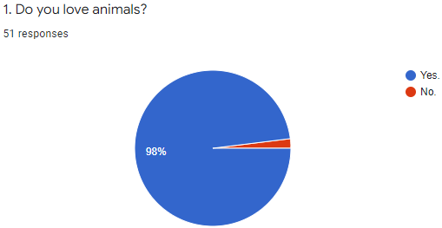 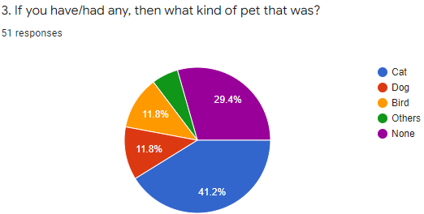

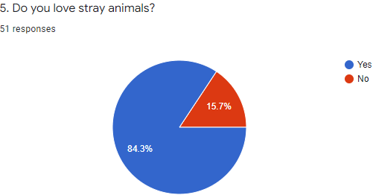

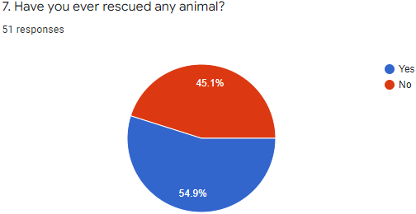

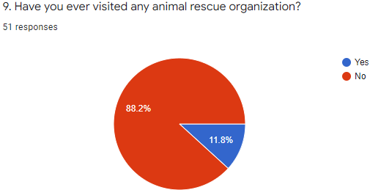

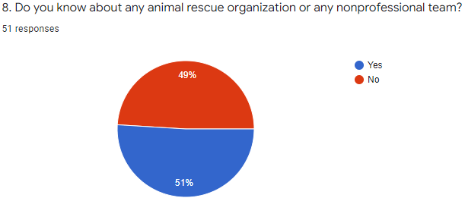

THE IMPORTANCE OF ANIMAL RESCUE| 12

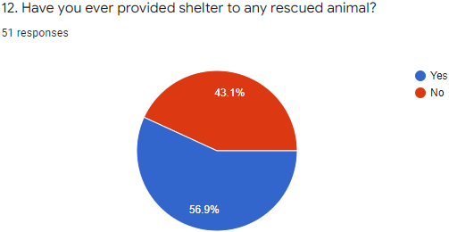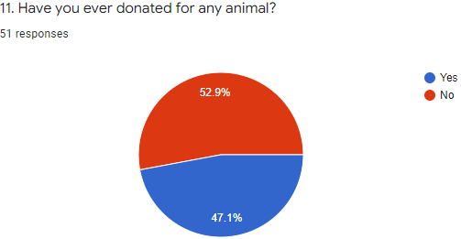

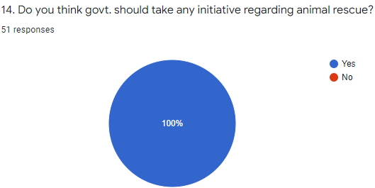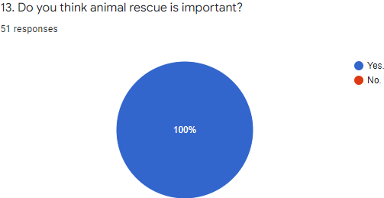

THE IMPORTANCE OF ANIMAL RESCUE| 13

***Conclusion and Recommendation***

After briefly discussing the topic “Importance of Animal Rescue in Bangladesh”, we can say that day by day animal rescuers are trying to expand their work and connections all around the country. We all should come forward to help them. Even the Govt. can help. We all know that it is not an easy task. But let’s speak for change.